# New features in FSW 3.4.4

This new release FSW 3.4.4 addressed the following items:

* Fixing of STATIC-TYPE reboot
* Management of PAS HIGH DATA RATE

## Fixing of STATIC-TYPE reboot

The reboot problem, known as “STATIC-TYPE reboot”, was due to a bad management inside SDPSW PANIC function in charge to manage error condition that erroneously activated an infinite loop blocking FSW.

This behaviour is fixed and new warnings are managed to notify the occurrence of the problem in flight. When the problem will occur in flight we should observe TM(5,2) like the one reported below:

TM ( 5,2) - 0x0E37 0xC023 0x0013 0x1005 0x0200 0x0000 0x00F4 0xA830 **0xAA2C** **0x00FF** **0x00FF** 0x0000 0xyyyy

Where 0xAA2C is the usual code identifying a SW warning, (0x00FF,0x00FF) identify a problem around PANIC management and 0xyyyy is a detailed information useful to continue debug investigation on ground.

## PAS HIGH DATA RATE

PAS data management implements a new scheme to allow a high data rate management, according to the following Figure 1.

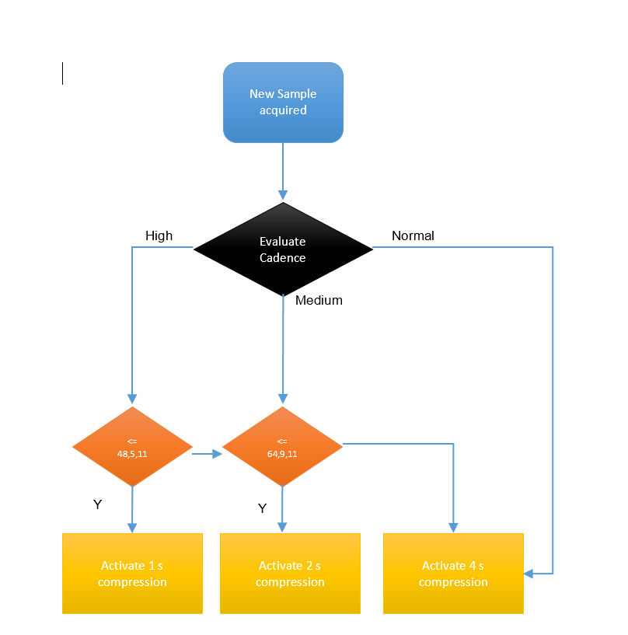

Figure 1: PAS HIGH RATE Management

To allow these different acquisitions mode, the cadence mode command was re-defined.

New cadence modes for PAS (green highlighted in Table 2 ) and a general flags to ignore/consider the cadence scheme for each of the sensors were added: in this way a change to one of the sensor will not affect the others that could be not interested in a cadence change.

|  |  |  |  |  |  |  |  |  |  |  |  |  |  |  |  |  |  |  |  |  |  |  |  |  |
| --- | --- | --- | --- | --- | --- | --- | --- | --- | --- | --- | --- | --- | --- | --- | --- | --- | --- | --- | --- | --- | --- | --- | --- | --- |
| *Word* | *0* | *1* | *2* | *3* | | *4* | | *5* | | *6* | | *7* | | *8* | *9* | *10* | | *11* | *12* | | *13* | *14* | | *15* |
| *1* | VN | | | TY | | DF | | **PID = 95 DEC** | | | | | | | | | | | PKT | | | | | |
| *2* | SF | | PSC | | | | | | | | | | | | | | | | | | | | | |
| *3* | PL | | | | | | | | | | | | | | | | | | | | | | | |
| *4* | SHF | PVN = 1 | | | | ACK | | | | | | | | **ST = 200** | | | | | | | | | | |
| *5* | **SS = 162** | | | | | | | | | | | | | SI | | | | | | | | | | |
| *6* | spare | | | | E1 | | E2 | | P | | H | | Eas1 R | | | | Eas2 R | | | PAS R | | | HIS R | |
| *7* | PEC | | | | | | | | | | | | | | | | | | | | | | | |
|  |  |  |  |  | |  | |  | |  | |  |  |  |  |  |  |  |  |  |  |  |  |  |
|  |  |  |  |  |  |  |  |  |  |  |  |  |  |  |  |  |  |  |  |  |  |  |  |  |

Table 1: Select Cadence Mode

|  |  |
| --- | --- |
| **Eas1 R** | Represent the new rate to be used to generate science products for EAS1.Valid values are:  ‘**00**’ = 10 sec  (high cadence)  ‘**01**’ = 100sec (nominal cadence)   ‘**10**’ = 400 sec (low cadence) |
| **Eas2 R** | Represent the new rate to be used to generate science products for EAS2.Valid values are:  ‘**00**’ = 10 sec  (high cadence)  ‘**01**’ = 100sec (nominal cadence)   ‘**10**’ = 400 sec (low cadence) |
| **PAS R** | Represent the new rate to be used to generate science products for PAS.Valid values are:  ‘**00**’ = 1 sec  (high cadence)  ‘**01**’ = nominal cadence (4s)  ‘**10**’ = low cadence  ‘**11**’ = medium cadence (2s) |
| **HIS R** | Represent the new rate to be used to generate science products for PAS.Valid values are:  ‘**01**’ = nominal cadence  ‘**10**’ = low cadence |
| **E1** | Ignore flag for EAS1:  1 = ignore  0 = use Eas1 R |
| **E2** | Ignore flag for EAS1:  1 = ignore  0 = use Eas2 R |
| **P** | Ignore flag for EAS1:  1 = ignore  0 = use PAS R |
| **H** | Ignore flag for EAS1:  1 = ignore  0 = use HIS R |

Table 2: Select Cadence Mode Fields details

In addition a new PAS normal mode cyclogram was designed to remove the Snapshot activation and allow 93 second of static acquisition plus a pseudo full acquisition (64x9x11) centered on the 100th second boundary to be used for peak tracking algorithm.

|  |  |  |  |  |
| --- | --- | --- | --- | --- |
| PAS “High Data Rate “ NORMAL MODE CYCLOGRAM | | | V2.1 20230303 |  |
| Offset to 100 s boundary, ms | DPU action | PAS command | Command argument | Comment |
| -3500 |  |  |  | This is offset of the LAST header of the previous interval. The header time stamp = 4500 + 92000 = 96500ms |
| -3300 | <staticWindow> = <FS Sampling> |  |  | <FS Sampling> is update from 0x3006 register |
| -3100 | Stop Static scheme | ***gotoIdleMode*** |  | This command is redundant, Just to be absolutely sure |
| -900 |  | ***loadStaticTable*** | <staticWindow> | From 0x3006 register Modifiable by new AIAFXXXX sequence |
| -800 | Start Static scheme | ***execStaticSampling*** | | FS execution |
| 1900 | <staticWindow> = <NM Sampling> |  |  | <FS Sampling> is update from 0x3005 register |
| 2000 | Calculate new window position |  |  | FS data processing |
| 3000 |  | ***gotoIdleMode*** |  |  |
| 3100 | Upload new Static scheme parameters | ***loadStaticTable*** | <NM sampling> From 0x3005 | Se, Ne, Sel, Nel, K, N = 93 From 0x3005, modifiable by AIAF068A |
| 3200 | Start Static scheme | ***execStaticSampling*** | |  |
|  | ﻿Go to the first line |  |  | At this point wait again -3300ms time |

Table 3: PAN NM cyclogram

Then, the PT Algorithm was refined according to A.Fedorov input :

if(Nel > 9) Nel = 9;

if(Ne > 92) Ne = 92;

if(Ne % 2 != 0) Ne--;

float fSe = (float)Max_Count_Ener - (float)Ne*0.61;

float fSel = (float)Max_Count_Elev - (float)Nel /2.0;

if(fSe < 0.0) Se = 0;

else

{

if(fSe + Ne >= 96) Se = 96 - Ne;

else Se = (unsigned int)(fSe + 0.51);//was Se = (unsigned int)(fSe + 0.49);

}

if(fSel < 0.0) Sel = 0;

else

{

if(fSel + Nel >= 9.0) Sel = 9 - Nel;

else Sel = (unsigned int)(fSel + 0.51);// Sel = (unsigned int)(fSel + 0.49);

}

# Testing approach for new FSW 3.4.4

Here below a general strategy able to test in MSSL the new features coming with FSW 3.4.4

## STATIC-TYPE reboot TEST

The problem generating the reboot is currently not Know, so a test should be performed to verify non-regression in normal science data operation. The following scenarios should be considered:

1. Scenario 1
   1. DPU in OPS
   2. All sensors in NM for x hours
2. Scenario 2
   1. DPU in OPS
   2. All sensors in BM for x hours

Scientific products shall be checked to verify correctness in content and delivery rate.

## PAS HIGH DATA RATE Test

### Cadence mode Test for EAS1,EAS2,HIS

The new command should be verified for EAS1, EAS2 and HIS in order to check the proper command execution.

All possible rates should be stimulated with both ignore flag enable and disabled.

### Cadence mode Test for PAS in Nominal configuration

The FSW 3.4.4 come with a new PAS NM Cyclogram that should be patched in MRAM, so any reboot upon this table patch will load in RAM the new NM cyclogram.

A couple of configuration parameter should be modified in RAM for different tests in order to verify the acquisition scheme depicted in Figure 1. These configuration parameters are:

* 0x3006 : allowing a Full sampling modification
* 0x3005 : allowing the NM sampling modification

Of course the configuration parameters should be changed while PAS in in IDLE mode.

Here below a table illustrating all combination of configuration parameters to be tested to verify nominal PAS Behaviour:

|  |  |  |  |
| --- | --- | --- | --- |
| ***0x3006*** | ***0x3005*** | ***Cadence*** | ***Expected*** |
| 64,9,11 | 48,5,11 | High | A sample each 1 second |
| 64,9,11 | 64,9,11 | Medium | A sample each 2 second |
| 64,9,11 | 92,9,11 | Nominal | A sample each 4 second |

Table 4: PAS NOMINAL HIGH RATE Configuration

Note, that PAS teams should also verify :

1. New PT algorithm
2. Correct cadence according to the new NM cyclogram

### Cadence mode Test for PAS in Erroneous configuration

Here below a table illustrating all combination of configuration parameters to be tested to verify bad PAS configuration:

|  |  |  |  |
| --- | --- | --- | --- |
| ***0x3006*** | ***0x3005*** | ***Cadence*** | ***Expected*** |
| 64,9,11 | 48,5,11 | Nominal | A sample each 4 second |
| 64,9,11 | 48,5,11 | Medium | A sample each 2 second |
| 64,9,11 | 64,9,11 | Nominal | A sample each 4 second |
| 64,9,11 | 64,9,11 | High | A sample each 2 second |
| 92,9,11 | 92,9,11 | High | A sample each 4 second |
| 92,9,11 | 92,9,11 | Medium | A sample each 4 second |

Table 5: PAS ERRONEOUS HIGH RATE Configuration