**SWA PAS Data Products**

Prepared by A. Fedorov 2018-03-05

The PAS Data Products flowchart is shown below.

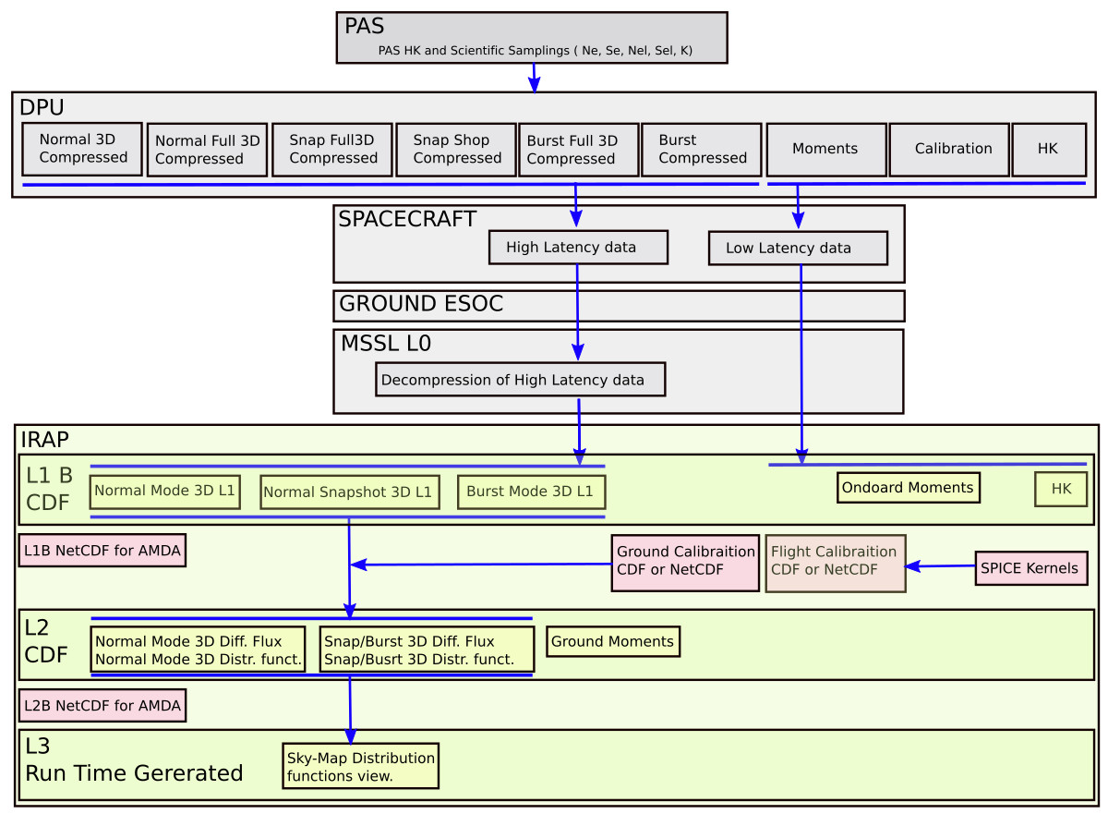

The detailed description of the Data Products:

**L0 PAS data**:

MSSL is responsible to extract PAS TM flow from the ESOC L0 data and decompress the DPU compression. The resulting L0 files are still L0 TM files looking as well as the DPU compression was OFF. This L0 data contains two separated data flows:

* High Latency data:
  + Normal Mode spectra
  + Normal Mode Snapshot spectra
  + Burst Mode spectra
* Low Latency data:
  + Onboard moments
  + Calibration Data
  + HKs

**L1B PAS Data**:

IRAP is responsible to generate CDF L1B PAS data form L0 source. The lest of L1B data products are as follows:

* Normal Mode Spectra in counts. The angular bin directions are in the PAS frame.
* Normal Mode Snapshot Spectra. The angular bin directions are in the PAS frame.
* Burst Mode spectra. The angular bin directions are in the PAS frame.
* Onboard moments in physical units. The frame reference is the PAS frame.
* HK values in the proper units (Voltages, Temperature, etc )

All Data products are made as CDF files according to “SOL-SGS-TN-0009 Metadata Definition for Solar Orbiter Science Data”

These files may be delivered to MSSL (TBD).

These files shall be stored in CDPP data archive. These files shall be converted also to NetCDF format to fit the AMDA tool spec.

**L2 PAS Data**:

IRAP is responsible to generate L2 data. To produce L2 data we need the auxiliary files as follows :

* L1B data products
* PAS Ground Calibration files
* PAS Flight Calibration files (Obtained from L0)
* SPICE kernels

IRAP is producing the L2 CDF files as follows:

* Normal mode 3D ion distributions expressed as a differential flux in the Solar-Ecliptic Frame
* Normal mode 3D ion distributions expressed as a distribution function in the Solar-Ecliptic Frame
* Snapshot and Burst fast 3D ion distributions expressed as a differential flux in the Solar-Ecliptic Frame
* Snapshot and Burst fast 3D ion distributions expressed as a distribution function in the Solar-Ecliptic Frame
* Ground calculated H+ moments in the Solar-Ecliptic Frame
* Ground calculated He++ moments in the Solar-Ecliptic Frame

All Data products are made as CDF files according to “SOL-SGS-TN-0009 Metadata Definition for Solar Orbiter Science Data”

These files may be delivered to MSSL (TBD).

These files shall be stored in CDPP data archive after a PI review and approvement. These files shall be converted also to NetCDF format to fit the AMDA tool spec.

All L2 data can be delivered to ESAC archive after a PI review and approvement.